Molecule Polarity and Intermolecular Forces

Intramolecular forces: Chemical bonds that hold molecules together.

Strength of intramolecular forces within a molecule affect polarity. This is caused by differences in electronegativities of the atoms participating in a chemical bond.
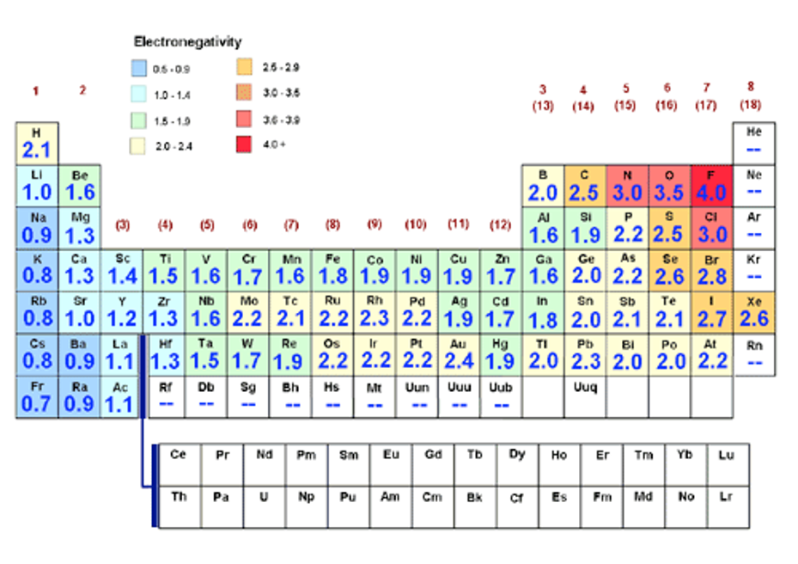

When 2 atoms are participating in a chemical bond, the differences in electronegativities between those atoms will determine the degree of polarity with respect to the bond.
- If the electronegativity difference is between 0 and 0.4, the bond is considered to be nonpolar.

- If the electronegativity difference is between 0.4 and 1.8, then the bond between the atoms is polar covalent. This means that the electrons are being shared between the 2 atoms in the bond, but the sharing is uneven. The electrons will be pulled more toward the more electronegative atom.

- If the electronegativity difference is higher than 1.8, the bond between the two atoms is considered ionic. No sharing of valence electrons. They are transferred completely to the more electronegative atom.

- If a molecule contains more than one polar bond, then the molecule as a whole can be polar, or nonpolar, depending on the strength and orientation of those polar bonds.

- It’s possible to have a nonpolar molecule with polar bonds, if those polar bonds are in opposite directions.

The penny test results show that water is “stickier” than ethanol. We could add more drops of water to the surface of the penny than drops of ethanol. Ethanol is also less polar than water. Is there any connection?

Intermolecular force: attractive forces between molecules. Can be strong or weak.
Types of intermolecular forces from strongest to weakest:
- Ion-ion interactions. Hold ionic compounds together in a crystal lattice by the attraction between oppositely charged ions.
- Hydrogen bonds. When hydrogen is covalently bonded to oxygen, nitrogen, or fluorine, creating a strong dipole in the molecule that exerts an attractive force on a neighboring molecule.

- Dipole – dipole interactions. When the positive end of one dipole molecule is attracted to the negative end of a neighboring dipole molecule.
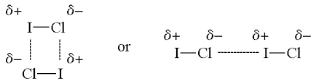

- Dipole – induced dipole interactions. When a dipole molecule gets close to a nonpolar molecule, and either the positive end of the dipole molecule attracts the electrons of the nonpolar molecule toward it, or the negative end of the dipole molecule repels the electrons on the nonpolar molecule. This creates a temporary dipole in the nonpolar molecule, which causes the two molecules to have a very fleeting attraction to each other.

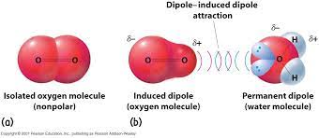

- Van der Waals forces / London Dispersion Forces. Induced dipole – induced dipole interactions. For a brief instant, the electron density in a nonpolar molecule shifts, so that the molecule becomes a temporary dipole that is able to induce a dipole in a neighboring molecule. Those two temporary dipoles then exert attractive forces on each other for an instant.
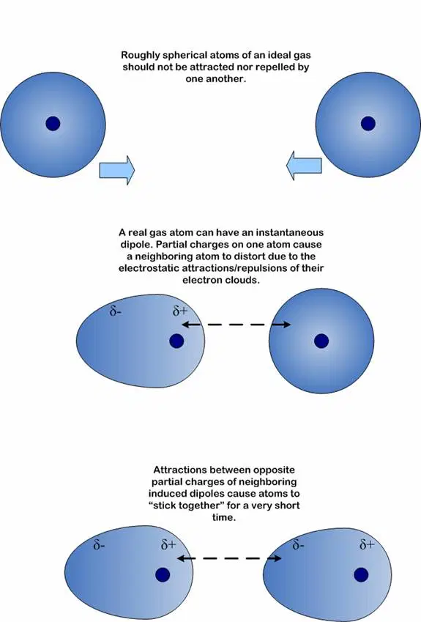

Intermolecular forces explain lots of properties that we observe in water, such as cohesion (water sticks to itself), adhesion (water sticks to other things), and surface tension.

What are some ways to test the strength of the intermolecular forces between molecules of a sample?

