Porifera (Sponge) Worksheet Biology 11 (51 marks)
- How does the name Porifera relate to the structure of a sponge? (2 marks)

- List five characteristics of all sponges. (5 marks)

- Describe how a sponge obtains and digests food. (3 marks)

- What is the function of the osculum in a sponge? (1 mark)

- What roles do amoebocytes play in sponges? (2 marks)

- How is being hermaphroditic an advantage to sponges? (2 marks)

- Describe asexual reproduction in sponges by: ( 3 marks)
  - Budding

  - Fragmentation & regeneration

  - Gemmules

- Describe sexual reproduction of Porifera, including details about the life cycle. (2 marks)

- What structures and materials make up the skeletons of Porifera? (3 marks)

Complete the table by writing a cell type or structure in sponges that fits each description. (4 marks)
Type of Cell or Structure | Description
10. | Aid in reproduction and nutrient transport. Helps produce spicules.
11. | Form the outside surface of the sponge body. Contract to close porocytes.
12. | Line the interior of sponges’ body.  Use flagella to draw water through pores.
13. | Found as a jellylike substance between the two layers.  Make up sponges’ support system.

Use each of the terms below just once to complete the passage. (7 marks)

External buds | Eggs | Hermaphroditic | Internal fertilization
Larvae | Sexual | Sperm

Sponges sometimes reproduce asexually by forming _14. . Being

15. , a sponge can produce both 16. and sperm. During

17. reproduction, 18 from one sponge fertilize the eggs of another. Fertilization can be external, but 19. is more common. Free- swimming 20. settle and develop into sessile adults.
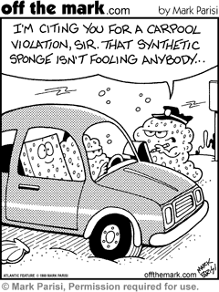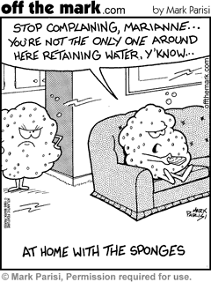

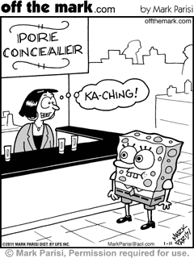
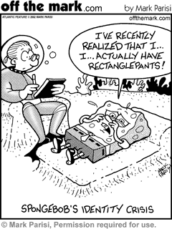

Anatomy of a Sponge Phylum Porifera
(17 marks)

- Label the structure.
- Give one function for each structure.
- 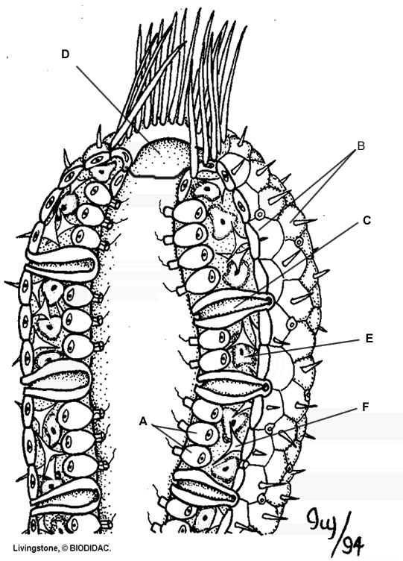Indicate whether the structure is found in the ectoderm layer, the endoderm layer, or the mesoglia.
A. 1.
2.
3.
B. 1.
2.
3.
C. 1.
2.
3.
D. 1.
2.
E. 1.
2.
3.
F. 1.
2.
3.

